CSD325-T301 Advanced Python
Module 5.2 Assignment: Forest Fire Simulation Flowcharts
Group-A | Rakesh Shrestha | Brandon Cox | Jerrold Icban | Christian Thompson
Overview: The flowcharts below model the program forestfiresim.py. The simulation starts by creating a random forest. The program then repeatedly shows the forest and updates it one step at a time. Each cell in the grid can grow a tree, catch fire from lightning, spread fire to neighbors, burn away, or stay the same. The loop continues until the user presses Ctrl-C to quit.
Figure 1 – Main Program Flow (main)

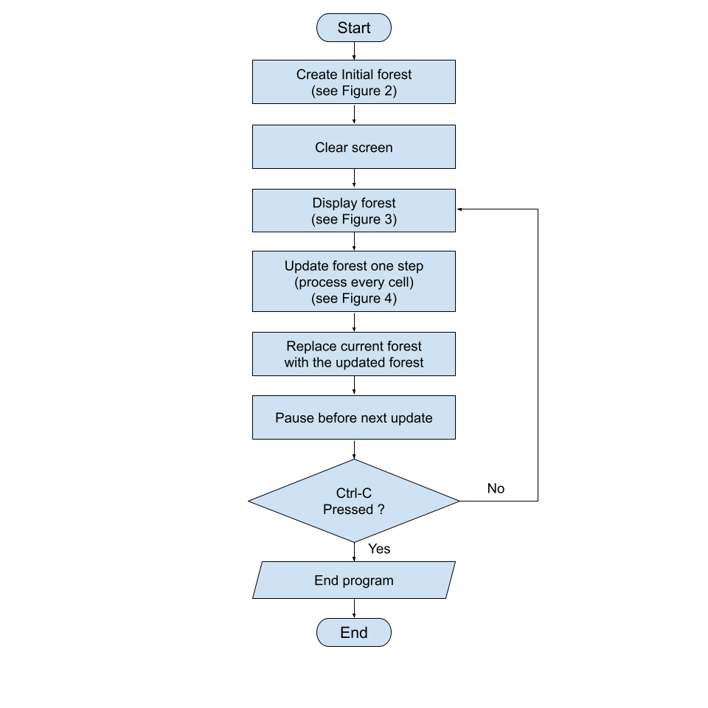
Figure 2 – Create Initial Forest (createNewForest)

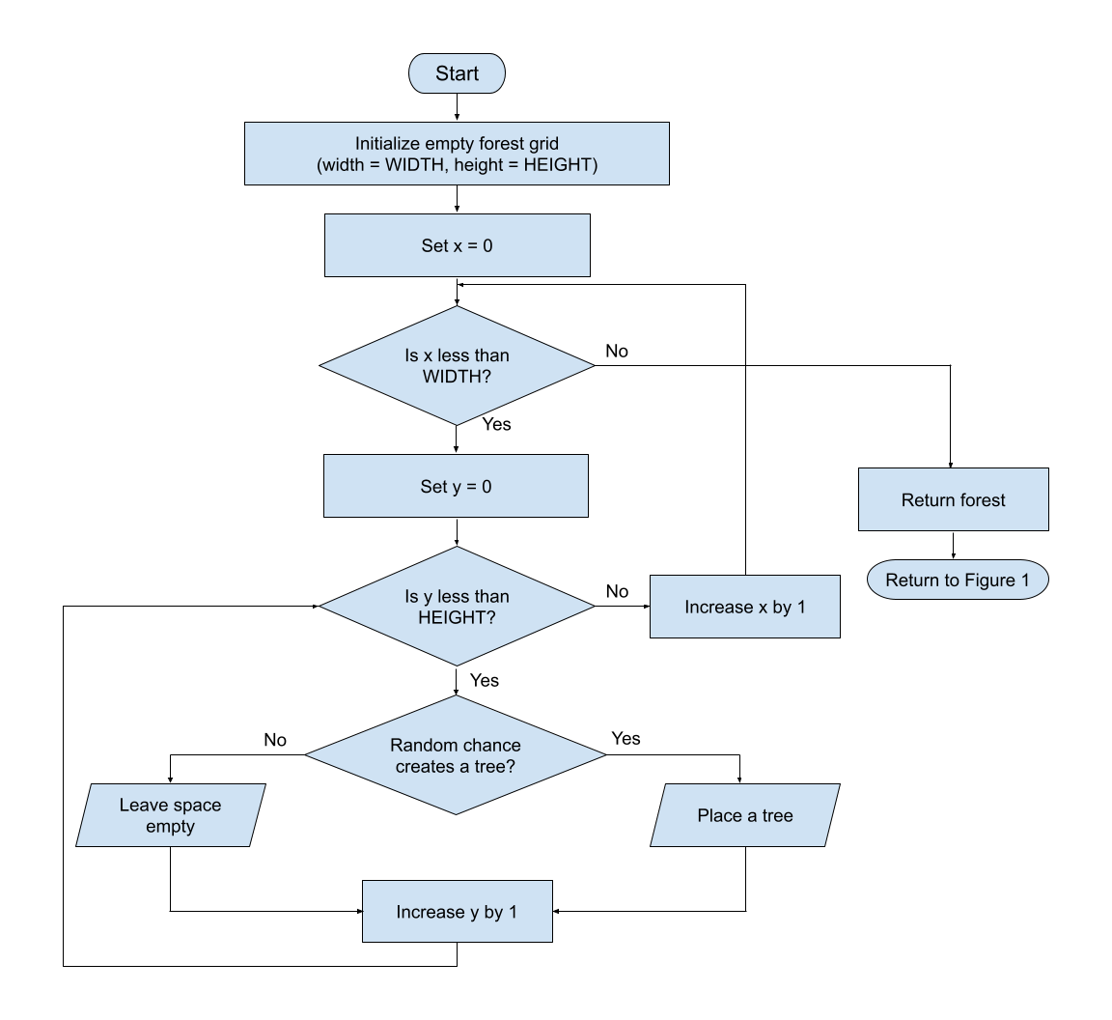

Figure 3 – Display Forest ( displayForest )

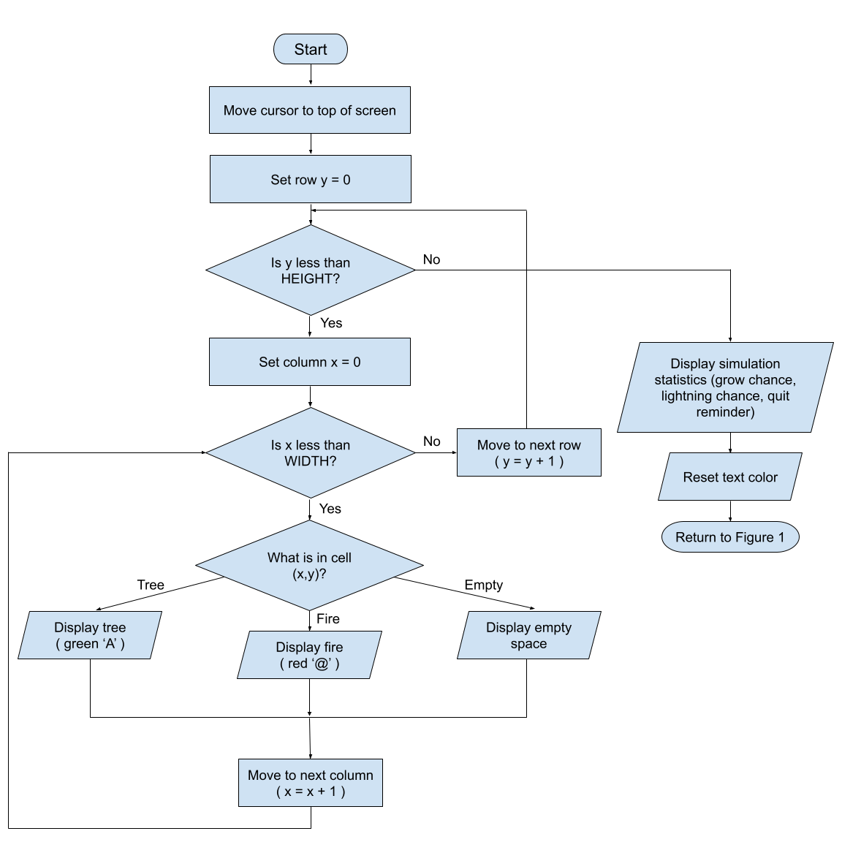

Figure 4 – Update One Cell ( Process Cell Logic )

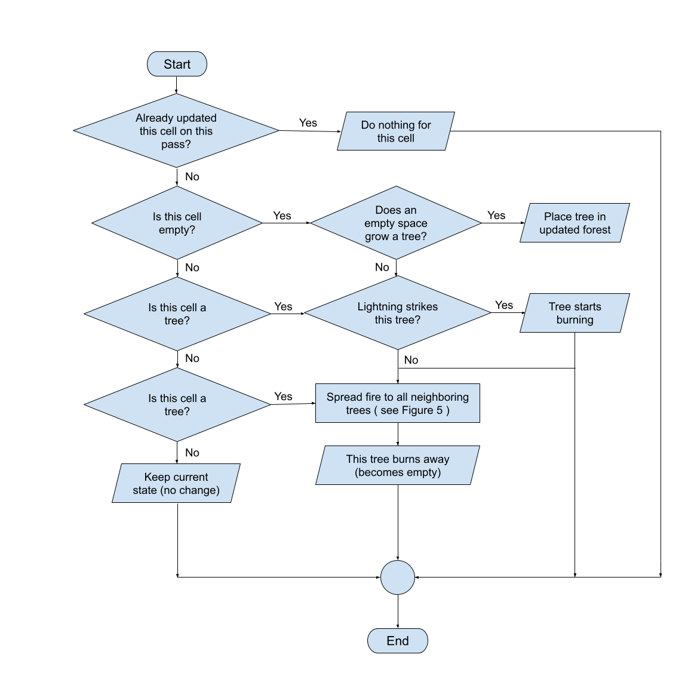

Figure 5 – Spread Fire to Neighboring Trees ( called from Figure 4 )

